Supplimentary:

S2. Sequencing Errors:

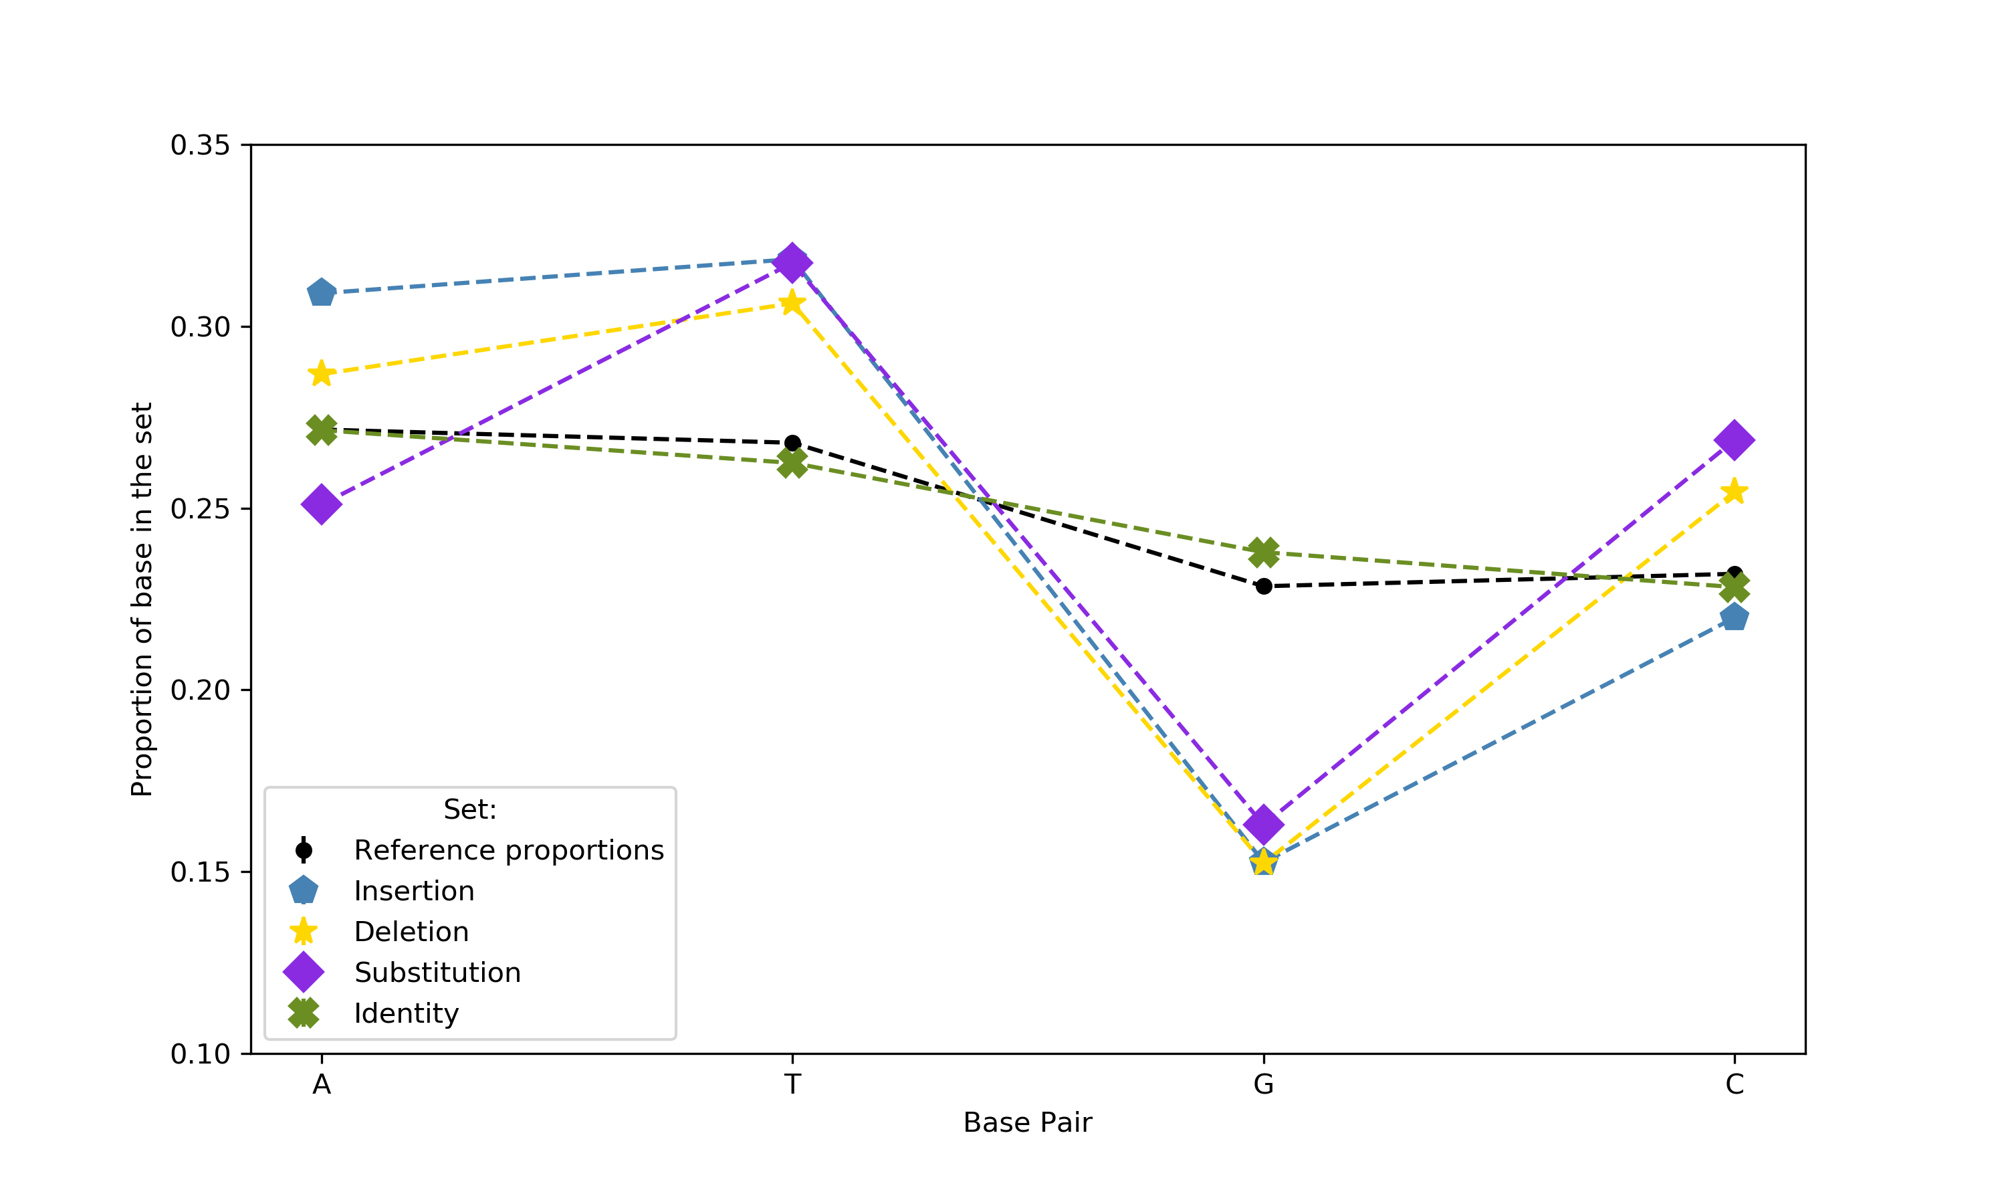

*Figure S2A: Nucleotide representation within the ERCC reference sequences (black dots) compared with the nucleotide representation within four categories from the ONT DRS read alignments; identity matches between the sequence of the read and the ERCC reference (green crosses), insertions (blue pentagons), delections (yellow stars) and substitutions (purple diamonds). Guanidine (G) is under-represented, and Thymine (T) is over-represented, for all three categories of error (insertion, deletion and substitution) relative to the reference nucleotide distribution). Cytosine (C) is over-represented in the set of deletions and substitutions. Adenine (A) is over-represented for Insertions and deletions and, under-represented in the set of substitutions.*

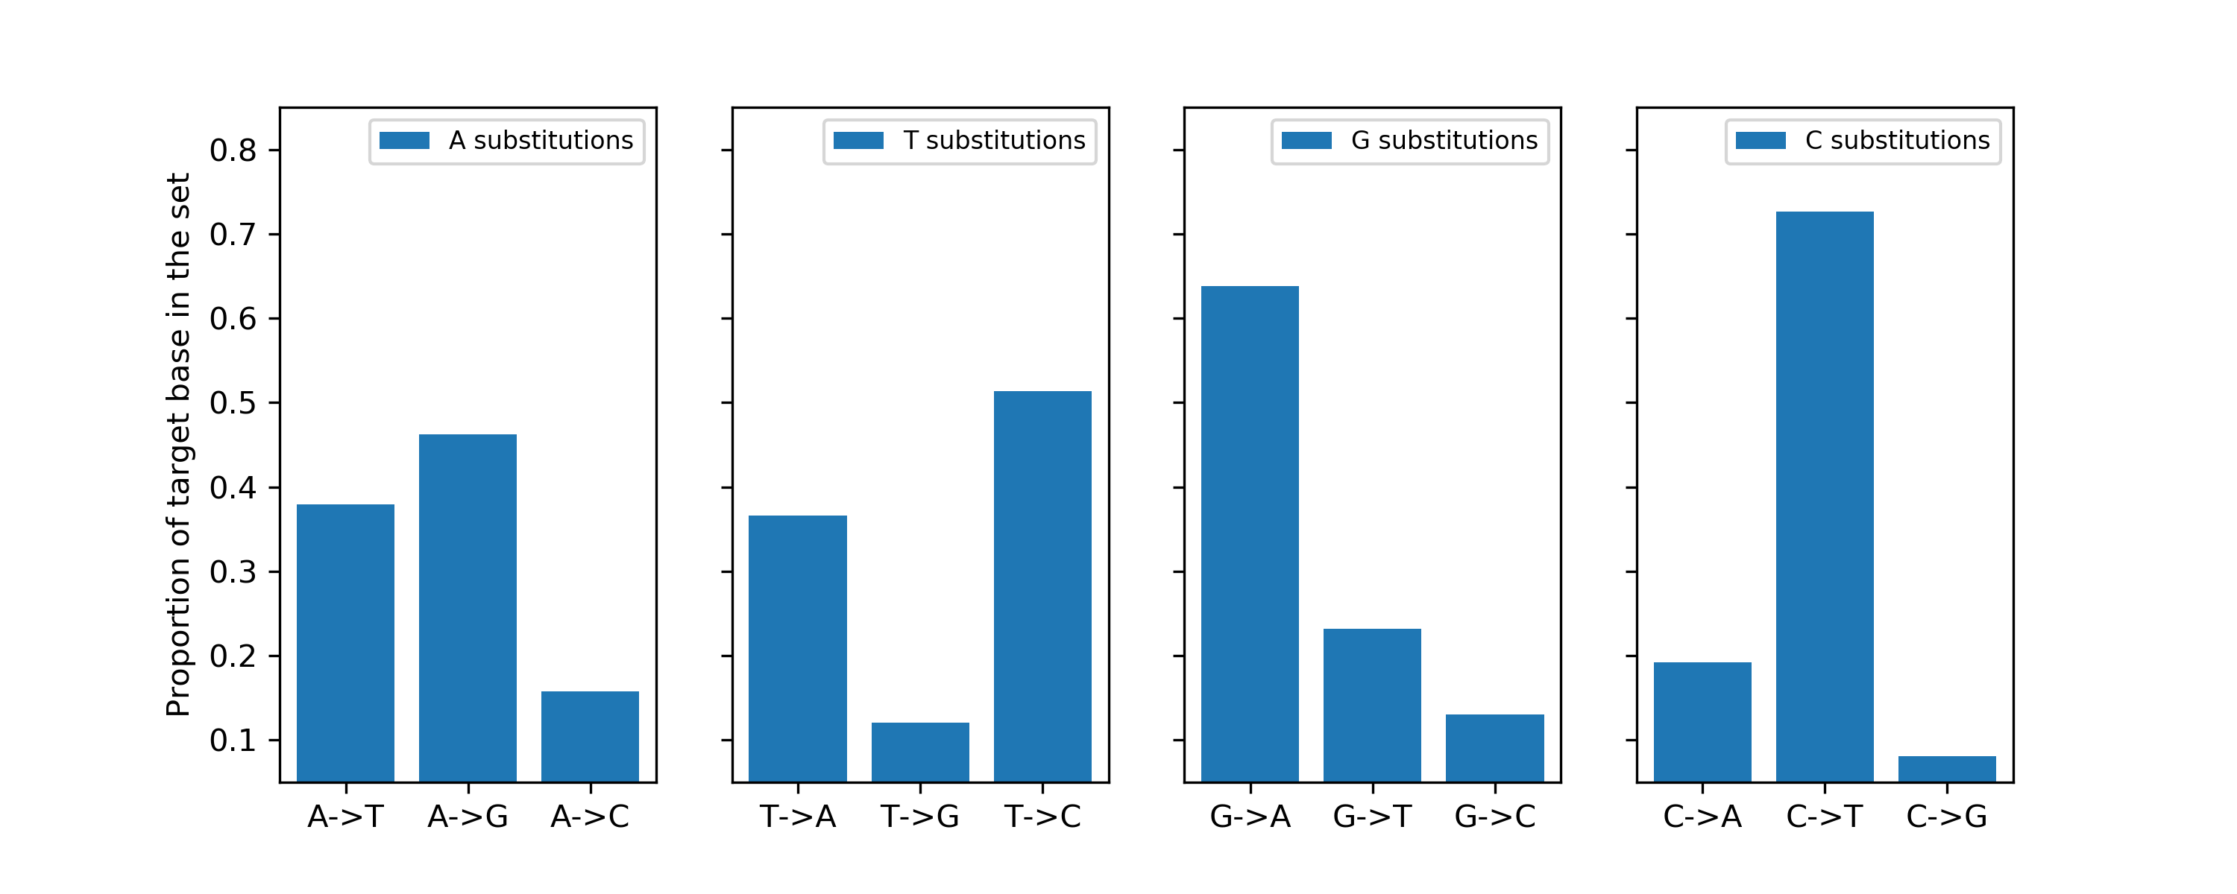

Figure S2B: Substitution preference for each Nucleotide (A, T, G, C, left-to-right). When substituted, Guanidine is replaced with Adenosine in more than 63% of its substitutions, while Cytosine is replaced by Thymine 73% of the time. Conversely Thymine is rarely replaced with Guanidine (12%) and Adenine is rarely substituted with Cytosine (16%).